EFFECT OF YTTRIA IN SINTERNG BEHAVIOR OF ALUMINA
A THESIS SUBMITTED IN PARTIAL FULLFILLMENT OF THE REQUIREMENTS FOR THE DEGREE OF BACHELOR OF TECHNOLOGY
By
SMRITI SAHU
Roll No: 10608020
Under the Guidance of
Prof. RITWIK SARKAR
DEPARTMENT OF CERAMIC ENGINEERING
NATIONAL INSTITUTE OF TECHNOLOGY
ROURKELA
2009-2010
NATIONAL INSTITUTE OF TECHNOLOGY
ROURKELA 2010
CERTIFICATE
This is to certify that the thesis entitled, “Effect of Y₂O₃ on the sintering behavior of Al₂O₃” submitted by Miss Smriti Sahu in partial fulfillment of the requirements of the award of Bachelor of Technology Degree in Ceramic Engineering at the National Institute of Technology, Rourkela is an authentic work carried out by her under my supervision and guidance.
To the best of my knowledge, the matter embodied in the thesis has not been submitted to any other university / institute for the award of any Degree or Diploma.

Dr. RITWIK SARKAR
Dept. of Ceramic Engineering
National Institute of Technology
Date: 7.5.2010 Rourkela – 769008

ACKNOWLEDGEMENT

I wish to express my deep sense of gratitude and indebtedness to Prof. Ritwik Sarkar, department of Ceramic Engineering, N I T Rourkela for introducing the present topic and for their inspiring guidance, constructive criticism and valuable suggestion throughout this project work. I would like to express my gratitude to Prof. J. Bera (Head of the Department), Prof. S. Bhattacharyya, Prof. S. K. Pratihar, Prof D. Sarkar Prof. S. K. Pal, Prof. R. Majumdar, Prof. A. Chowdhury for their valuable suggestions and encouragements at various stages of the work. I am also thankful to all staff members of Department of Ceramic Engineering NIT Rourkela.

I am also grateful to Mr. Rajesh (Department of Metallurgy and Material Science) for helping me for doing SEM and analysis of my samples.

I am also thankful to research scholars in Department of Ceramic Engineering for helping me out in different ways.

Last but not least, my sincere thanks to all my friends who have patiently extended all sorts of help for accomplishing this undertaking.

7th May 2010 (SMRITI SAHU)
CONTENTS
CERTIFICATE
ACKNOWLEDGEMENT
LIST OF TABLE
ABSTRACT
CHAPTER 1 ~ INTRODUCTION 7
1.1 Background 8
1.2 Extraction Routes 8
1.3 Typical Characteristics 9
1.4 Crystal Structure 9
1.5 Alumina Grades 10
1.6 Sintering of Alumina 11
1.8 Applications 11
1.8 Yttria 11
CHAPTER 2~ LITERATURE REVIEW 12
2.1 What is sintering 15
2.2 Different types of sintering 15
2.3 Different stages of sintering 16
2.4 Mechanism of Solid State Sintering 17
2.5 Example of Solid State Sintering 17
2.6 From Literature 18
CHAPTER 3~ PROBLEM STATEMENT 23
CHAPTER 4~ EXPERIMENTAL 24
4.1 Raw Material Used 24
4.2 Compaction into pellets 24
4.3 Drying of pellets 24
4.4 Sintering 25
4.5 Bulk Density and Apparent Porosity 26
4.6 Phases in Sinteres pellets 27
4.7 Microstructural analysis by SEM………………………………………………………….27
CHAPTER 5 ~ RESULTS AND DISCUSSIONS 28
5.1 XRD analysis 28
5.2 Shrinkage 31
5.3 Apparent Porosity and Bulk Density of sintered pellet 31
5.4 SEM analysis 32
5.5 EDAX 34
CHAPTER 6~ CONCLUSION 36
CHAPTER 7~ REFERENCES 37

ABSTRACT
Densification of alumina has been studied in the present work in presence of yttria. Yttria as dopant has been added to the extent of 0.5, 1 and 2 weight % to pure alumina and studied for pressure-less sintering. Pellets of without and with yttria containing compositions were sintered at 1550⁰C 1600⁰C, 1650⁰C and then characterized for densification, phase analysis and SEM & EDAX studies. A new phase, Y₃Al₅O₁₂, has been observed in the sintered samples indicating reactions between alumina and dopant phase. Results reveal that yttria is a beneficial sintering additive for alumina on sintering at 1650⁰C, at lower temperatures it has a hindering effect on sintering. Microstructural study indicates the improvement and EDAX study confirm the presence of yttrium and aluminium containing oxide phases, observed as brighter grains.

Chapter 1~~ INTRODUCTION

Chemical Formula: Al₂O₃
1.1 Background
Aluminium Oxide (Al₂O₃) or alumina is one of the most versatile of refractory ceramic oxides and finds use in a wide range of applications. It can exist in several crystalline phases which all revert to the most stable hexagonal alpha phase at elevated temperatures. This is the phase of particular interest for structural applications.
Alpha phase alumina is the strongest and stiffest of the oxide ceramics. Its high hardness, excellent dielectric properties, refractoriness and good thermal properties make it the material of choice for a wide range of applications.
High purity alumina is usable in both oxidizing and reducing atmospheres to 1925°C.Weight loss in vacuum ranges from 10^{–7} to 10^{–6} g/cm².sec over a temperature range of 1700° to 2000°C. It resists attack by all gases except wet fluorine and is resistant to all common reagents except hydrofluoric acid and phosphoric acid. Elevated temperature attack occurs in the presence of alkali metal vapors particularly at lower purity levels.
It is found in nature as corundum in emery, topaz, amethyst, and emerald and as the precious gemstones ruby and sapphire, but it is from the more abundant ores such as bauxite, cryolite and clays that the material is commercially extracted and purified.
Corundum exists as rhombohedral crystals with hexagonal structure. The unit cell is an acute rhombohedron of side length 5.2Å and plane angle ~55°. It is the close packing of the aluminium and oxygen atoms within this structure that leads to its good mechanical and thermal properties. [11]
1.2 Extraction Routes
The most common process for the extraction and purification of alumina is the ‘Bayer’ process. The first step in the process is the mixing of ground bauxite into a solution of sodium hydroxide. By applying steam and pressure in tanks containing the mixture, the bauxite slowly dissolves. The alumina released reacts with the sodium hydroxide to form sodium aluminate. After the contents of the tank have passed through other vessels where the pressure and temperature are reduced and impurities are removed, the solution of sodium aluminate is placed in a special tank where the alumina is precipitated out. The precipitate is removed from the tank, washed, and heated in a kiln to drive off any water present. The residue is a commercially pure alumina.
Other extraction processes are used including pyrogenic treatment of bauxite with soda, and the extraction of aluminium hydroxide from metakaolin via either the chloride or sulphate.
The yield of alumina from these processes can approach 90%.
For advanced ceramics uses, the alumina manufactured by these processes requires further purification. This is often achieved by recrystallisation from ammonium alumina. [11]

1.3 Typical Alumina characteristics include:
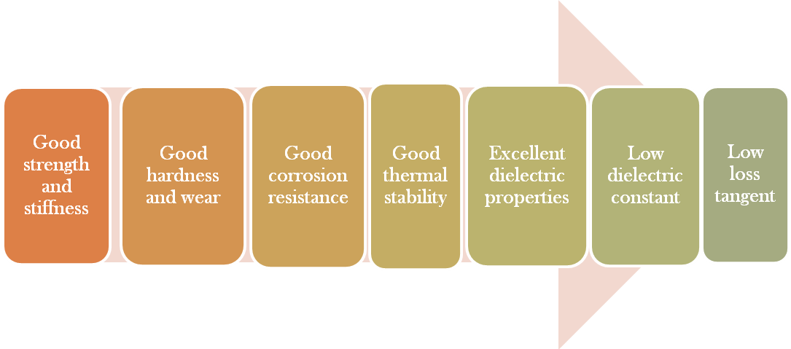
- Good strength and stiffness
- Good hardness and wear resistance
- Good corrosion resistance
- Good thermal stability
- Excellent dielectric properties (from DC to GHz frequencies)
- Low dielectric constant
- Low loss tangent

1.4 Crystal Structure
The most available form of crystalline alumina i.e. α-aluminium oxide is known as corundum. Corundum has a trigonal Bravaice lattice. Each unit cell contains six formula units of aluminium oxide. The oxygen ions nearly form a hexagonal close-packed (HCP) structure with aluminium ions filling two-thirds of the octahedral interstices.
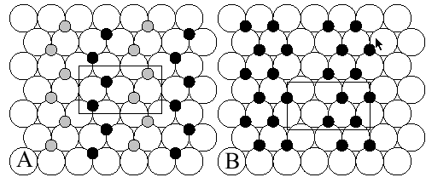
Fig 1.2 Schematic drawing of the first two layers in alumina structure. Octahedral Al ions are black, tetrahedral are grey.
1.5 Alumina grades:
90-97% Alumina -Best suited for metallurgy because of the large grain structure.
98-99.5% Alumina-Commonly range of isostatically pressed grades with extruded shape also available at low cost.
- Tolerance- As fired alumina’s tolerance are generally only possible within a within a few percentage of dimension externally high tolerance are attainable but only by precise machining, the fired part using the diamond grinding technique.
1.6 Sintering of alumina:
Sintering of alumina is done in two ways:
(a) Solid state sintering where we need purity more than 99.7%.
(b) Liquid state sintering where we need purity from 80-99.7%.
Solid state sintering requires exclusively for translucent Al₂O₃ ceramics, because presence of pores arises scattering of visible light which from opaque alumina to get to get a very pure alumina body, sintering can be done by 3 solid state process, we require high temperature (>1900°C) ,still the body contains 5% porosity and abnormal grain growth.
To overcome this problem, Alumina is sintered using 0.25 Wt% of MgO and sintering at the temperature range of 1700-1800°C in H₂ atmosphere, to make the body translucent.
By the micro structural observations we revealed that MgO eliminates the discontinuous grain growth of Al₂O₃, and grain boundaries do not break away from pores which prevents the inclusion of pores trapped inside the new grain with long diffusion path for densification.
The majority of MgO doped into alumina resides at the grain boundaries because the dissolution of MgO in alumina is small. This leads to solute drag mechanism which reduces the boundary mobility and hence prevents abnormal grain growth, and pores also are attached to the boundary that’s why pores can be easily mobile.
Reactive alumina:
Type of alumina which are sinterable to nearly theoretical density at relatively low temperature i.e. at range of 1550- 1600°C, that is why alumina is called reactive alumina with respect to sintering.
Our sample name is A 17 NE and its reactive alumina.

1.7 Applications:

With such a wide range of composition and properties, alumina ceramics find a wide range of applications. Some of the major application areas can be grouped as

High Temperature and Aggressive Environments
Its high free energy of formation makes alumina chemically stable and refractory, and hence it finds uses in containment of aggressive and high temperature environments.

Wear and Corrosion Resistance
The high hardness of alumina imparts wear and abrasion resistance and hence it is used in diverse applications such as wear resistant linings for pipes and vessels, pump and faucet seals, thread and wire guides etc.

Biomedical
High purity alumina is also used as orthopedic implants particularly in hip replacement surgery.

Metal Cutting Tools
The high “hot” hardness of alumina have led to applications as tool tips for metal cutting (though in this instance alumina matrix composites with even higher properties are more common) and abrasives.

Milling Media
Alumina is used as milling media in a wide range of particle size reduction processes.

Microwave Components
The high dielectric constant coupled with low dielectric loss particularly at high frequencies leads to a number of microwave applications including windows for high power devices and waveguides.

Electrical Insulation
The high volume resistivity and dielectric strength make alumina an excellent electrical insulator which leads to applications in electronics as substrates and connectors, and in lower duty applications such as insulators for automotive spark plugs. [11]

1.8 Yttria
Yttrium Oxide is mainly extracted from the mineral Xenotime (YPO₄). Its properties include high thermal stability and good transparency to infrared radiation. It has an affinity for oxygen and sulphur and is used as an additive to stabilize Zirconia and as a sintering aid in Sialons and silicon nitride. As an optical ceramic, it transmits well in the infrared range, from 1 to 8 microns wavelength. The high infrared transmission, together with good resistance to erosion and thermal shock, makes it ideal for protection domes for infrared sensors. Yttrium oxide can be used in the application of optical sensors with high sensitivity or X-ray detection material. Yttrium oxide is the most thermodynamically stable oxide available. Yttrium oxide-based materials are used as thermal barrier coatings. Any high temperature container or structural component (be it either graphite, ceramic or metal) that is contacted by reactive molten metals(such as uranium, titanium and their alloys) or other reactive material can be protected using yttrium oxide. In effect, the reactive material sees only Y₂O₃, which is applied as a thin, economical layer, and substrate interaction is thus prevented. Whenever metal purity is a prime consideration during melting and casting operations, Y₂O₃ can be considered the most chemically resistant material available. Yttria is used as a sintering aid in sialons and silicon nitride. Yttrium oxide is used as an additive to stabilize zirconia and to enhance the fracture toughness
Structure
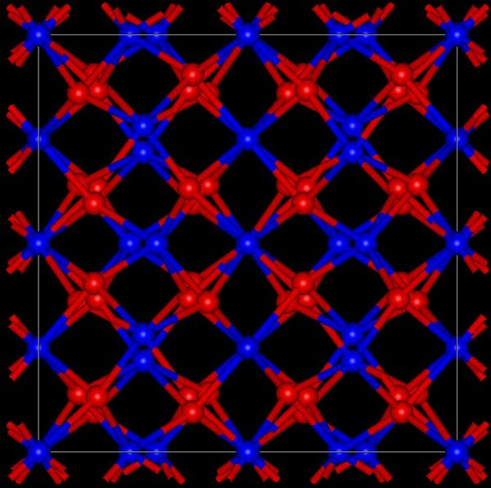

CHAPTER 2~~ LITERATURE REVIEW

2.1 What is sintering?

Thermal treatment that bonds particles together into a solid, coherent structure by means of mass transport mechanisms occurring largely at the atomic level is called sintering.
Mass movements which occur during sintering consist of the reduction of total porosity by diffusion followed by material transport. Mostly density of a collection of grains increases as material flows into voids, causing a decrease in overall size.
The initial powder (green body) has a large surface area relative to its volume. This surface area provides the driving force in sintering, which is the reduction of free surface energy resulting from the surface area of the particles.

2.2 Different types of sintering:
Sintering is basically of two types…..
- Solid state sintering: In this, all densification is achieved through changes in particle size and shape without rearrangement or the presence of liquid phase.
- Liquid assisted sintering: In this a liquid phase coexists with a particulate solid at the sintering temperature during atleast some part of thermal cycle.

2.3 Different stages of sintering
1. Initial stage of sintering:
(a) Initially there is formation of local point of fusion without shrinkage of compact.
(b) After some time as temperature increases, there is a neck formation at the contact point with the resulting concave curvature at the neck.
2. Intermediate stage of sintering:
(a) There is formation of necks, and neck growth
(b) Pores forming arrays of interconnected cylindrical channels.
(c) Particles centers approaching one another, with the resulting compact shrinkage.
(3) Final stage of sintering
(a) Isolation of pores i.e. relative densityexceeding-93%.
(b) Elimination of porosity.
(c) Grain growth.
2.4. Mechanism of solid state sintering:
Polycrystalline materials sinter by diffusional transport of matters whereas amorphous materials sinter by viscous flow. In polycrystalline, materials matter transport takes place along definite paths that define the mechanism of sintering. Matter is transported from the regions of higher chemical potential to region of lower chemical potential. There are six different mechanism of sintering in polycrystalline materials.
- Surface diffusion
- Lattice diffusion
- Vapor transport
- Grain boundary diffusion
- Lattice diffusion
- Plastic flow
Surface diffusion, lattice diffusion and vapor diffusion are the only mechanism which leads to the actual densification but all causes the neck to grow and so influences the rate of densification.
While the amorphous materials viscous flow leads to neck growth as well as the densification.
2.5. Example of solid state sintering:
To enhance the slow in diffusion the one are enhanced or encouraged through the following method:
- Chemical doping
- Atmospheric control
- An appropriate time per temperature cycle
Sintering of Al₂O₃ with aid of MgO: MgO is added into the Al₂O₃ in a very small amount 0.25 wt% of Al₂O₃ content. This allows the achievement of fine-grained material at full. During microstructure studies revealed that MgO eliminates the discontinuous grain growth of Al₂O₃ grains. The grain boundaries do not break away from the pores, which prevents the inclusion of pores trapped inside new large grains, with slow/long diffusion path densification.
The mechanism by which MgO slowdown grain boundary movements in alumina could be as following:
- The majority of MgO doped into Al₂O₃ resides at the grain boundaries, because the dissolution of MgO in Al₂O₃ is small or 300 ppm. This is due to the relatively large difference in ionic radius, 0.72 À for Mg²⁺ and 0.53 À for Al³⁺.
- Any fast migration of the grain boundary would have to incorporate Mg²⁺ ions into the Al₂O₃ lattice, will the resulting increase in internal energy, unless a new compound spinel forms. [1, 2, 3].
2.6 From Literature:
- In order to obtain information about the alumina scalegrowth mechanism, oxygen (¹⁸O) and aluminium (²⁶Al) self-diffusion coefficients in Al₂O₃ were determined in the same materials and in the same experimental conditions, thus allowing a direct comparison. For both isotopes, bulk and sub-boundary diffusion coefficients were determined in single crystals of undoped alumina. Grain-boundary diffusion coefficients have been computed only for oxygen diffusion in polycrystal. Oxygen diffusion has been also studied for yttria-doped -alumina in the lattice, sub-boundaries and grain boundaries. Oxygen and aluminium bulk diffusion coefficients are of the same order of magnitude. In the sub-boundaries, aluminium diffusion is slightly faster than oxygen diffusion. Yttria doping induces a slight increase of the oxygen bulk diffusion, but decreases the grain-boundary diffusion coefficients on account of segregation phenomena. These results are compared with the oxidation constants of alumina former alloys (alloys which develop an alumina scale by oxidation). It appears that neither lattice self-diffusion nor grain boundary self-diffusion can explain the growth rate of alumina scales. Such a situation is compared to the case of Cr₂O₃.[4]
- They investigated the mechanisms, the influence of minor additions of Y₂O₃ on the sintering kinetics of Al₂O. The conclusion that Y₂O₃ additions in Al₂0₃ play a beneficial role on the sintering rate, at least for Y₂O₃ contents up to 1% and for a comparable size of the two powders. It is known that sintering is controlled by diffusion processes. Consequently these results show that minor additions of Y₂O₃ increase the diffusion rate in Al₂0₃ and hence the mobility of the vacancies. This increase in mobility should improve the plasticity of the Al₂O₃. These proposals agree with recent investigations which show that an addition of 90 ppm Y in an Fe-Ni43-Cr,-Al, alloy decreases the stresses in the oxide scale developed by oxidation at 1000 ⁰C.[5]
- In yttrium co-doped alumina, the distribution of yttrium during grain growth is affected by the grain size and the total content in yttrium. Consequently, two different kinds of microstructure are observed: a microstructure with grain boundary segregation of yttrium only and a microstructure which shows both grain boundary segregation and intergranular precipitates rich in yttrium. It is shown that yttrium added to alumina in addition to magnesia does not affect grain growth; this phenomenon seems to be mainly controlled by the magnesia.[6]
- Some points arise from the comparison of the three sets of data: (1) the Y ³⁺ diffusion coefficients are very close to those of Cr³⁺ in the whole temperature range, and (2) around 15OO⁰C, Y³ ⁺ and Cr³ ⁺ diffusion coefficients are one order of magnitude higher than those of Al³⁺ .The ion size is not a reliable criterion for predicting variations in foreign element diffusion coefficients in alumina.[7]
- The dielectric loss of alumina ceramics doped with various amount of yttria was investigated. It is hard to put the Y³⁺ ion into the Al–O octahedron of corundum structure of alumina to form a solid solution of intermission and substitution, and the Al₅Y₃O₁₂ secondary phase is observed. The dielectric loss increases generally from 8.4×10−5 to 2.2×10−4, with yttria doping. The secondary phase increases the dielectric loss, and the optimum grain size is beneficial to oppress the dielectric loss.[8]
- The grain growth and densification have been investigated in very high-purity α-alumina doped with varying amounts of yttrium (0 to 3000 wt ppm of yttria) and sintered in air at 1450, 1550 and 1650 °C. Yttrium doping inhibited densification and coarsening at 1450 °C, but had very little effect at 1550 °C and no effect at 1650 °C. The change in densification behavior is suggested to be related to the transition with increasing temperature from grain boundary diffusion to lattice diffusion controlled densification. The coarsening rate increases faster with temperature than the densification rate. This was correlated with a higher measured activation energy for grain growth than for the diffusion processes, which control the densification.[9]
- Final-stage sintering has been investigated in ultrahigh-purity Al₂O₃ and Al₂O₃ that has been doped individually with 1000 ppm of yttrium and 1000 ppm of lanthanum. In the undoped and doped materials, the dominant densification mechanism is consistent with grain-boundary diffusion. Doping with yttrium and lanthanum decreases the densification rate by a factor of ∼11 and 21, respectively. It is postulated that these large rare-earth cations, which segregate strongly to the grain boundaries in Al₂O₃, block the diffusion of ions along grain boundaries, leading to reduced grain-boundary diffusivity and decreased densification rate. In addition, doping with yttrium and lanthanum decreases grain growth during sintering. In the undoped Al₂O₃, surface-diffusion-controlled pore drag governs grain growth; in the doped materials, no grain-growth mechanism could be unambiguously identified. Overall, yttrium and lanthanum decreases the coarsening rate, relative to the densification rate, and, hence, shifted the grain size-density trajectory to higher density for a given grain size. It is believed that the effect of the additives is linked strongly to their segregation to the Al₂O₃ grain boundaries.[10]
Effect of Y₂O₃ on Alumina:
Y₂O₃ is added in alumina as sintering aid, which brings down temperature of sintering by creating stearic hindrance in alumina structure, solid solution forms when they show deviation from the Hume-Ruther rule.
Hume Rothary Rule: (Substitutional solid solution):
- Valancy should be same.
- Electronegativity should be similar
- Size difference should be within 15%.
Although valence state of Al³⁺ and Y³⁺ and electronegativity are same, but there is difference in atomic radii of Y³⁺ and Al³⁺.
We have atomic radii of Y³⁺ and Al³⁺ as 1.06 A⁰ and 0.53⁰A respectively. Y substitutes Al and vice-versa in the lattice structure. As there is difference in size so only partial substitution takes place. Size of Y is higher than Al, so substitution causes lattice strain which leads to higher system energy hence leading to lower sintering temperature and higher density.
As per literature, we get:
- The sintering kinetics of Al₂O₃ is increased by a small addition of Y₂O₃. For an addition of 1% Y₂O₃ kinetics is slower than for pure Al₂O₃ [5].
- The sintering kinetics increases with decreasing size of Y₂O₃ particles and optimum rate is reached for approximately equal sizes of Y₂O₃ and Al₂O₃ particles.[5]
- Final stage of sintering has been investigated in ultrahigh purity Al₂O₃ and Al₂O₃ doped with 1000pm of Yttrium. In doped and undoped materials densification mechanism is consistent with grain boundary diffusion. Doping decreases the densification rate by a factor 11. It is inferred that large rare earth cations which segregate strongly to grain boundary in Al₂O₃, block the diffusion of ions along grain boundaries, leading to reduced grain –boundary diffusivity and decreased densification rate.[10]
Overall, Yttrium decreases the coarsening rate relative to densification rate and hence shifted the grain size-density trajectory to higher density for a given grain size.

CHAPTER 3~~PROBLEM STATEMENT:

- To study the effect of Y₂O₃ at the three different percentage of additive at three different temperature
We have three batches which contains different wt% of Y₂O₃ as additive in alumina containing 0.5 wt%, 1 wt% and 2wt%, one batch of 50 gm of 100% pure alumina or 0% Y₂O₃ is made which helps to find the difference between the above batches after sintering at different temperatures, 1550⁰C, 1600⁰C and 1650°C, The soaking time at pick temperature in each process is 2 hours.
- Determination of Shrinkage, Apparent Porosity, Bulk Density and observing the variation.
- Studying the phases by XRD.
- Studying the surface morphology by SEM.
- Elemental analysis by EDAX study of the sintered samples.

CHAPTER 4 EXPERIMENTAL WORK
4.1 The raw materials used are
- Alumina powder- A 17 NE from ALMATIS GERMAN
- Yttria powder
First of all 4 batches of 50 grams each were made in which different percentage of Yttria(0.5%, 1%, 2%) were added into 3 batches of Alumina such that the whole batch forms a combine weight of 50gm.
4.2 Compaction into pellets:
After weighing and addition of the dopant, 3ml of 2% PVA solution was added as binder. After mixing it for 5 min, the material is sieved 3 times by 500µm sized sieve so that we can get proper mixing.
Now sub-batches of 2.2 gm from each batch are separated to form pellets with a die pressed by Hydraulic Press (carver press USA) at pressure 1.5 ton on 1.2 mm area with a holding time of 60 sec. Stearic acid is used as lubricant.
4.3 Drying of pellets
After preparing the pellets, they were dried for 24 hrs at 110⁰C.
After drying dimensions were measured for each pellet using Vernier Calliper.

4.4 Sintering of pellets:
Now, from each batch 3 pellets were taken and sintered at 1550⁰C, 1600⁰C and 1650⁰C with soaking time of 2 hrs. After sintering, shrinkage is calculated.
4.5 Bulk Density and Porosity of sintered pellets:
The bulk density and apparent porosity of the sintered pellets were determined by Archimedes principle using water. Dry Weight is measured and then the pellets were kept in distil water and then vacuuming is done in place of boiling for about 45 min-1 hr. After that suspended weight is measured using apparatus in which pellet is suspended in water and weight is measured. After taking suspended weight, soaked weight is taken. Hence the dry weight, soaked weight and suspended weight were measured. The bulk density and apparent porosity were calculated by the formulas:
Bulk Density = dry weight / (soaked weight – suspended weight)
Apparent porosity= (soaked weight-dry weight) / (soaked weight – suspended weight)
4.6 Phases in sintered powder:
The sintered pellets were powdered of 2% composition at 1550⁰C and 1650⁰C along with 0% at 1550⁰C were subjected to phase analysis by X-ray diffraction (PW1830 Diffractometer, Phillips, and Netherland).
This is done to know the different phases present in the calcined powder. The angle range was 10º-50º.
4.7 Microstructural analysis by SEM
The sintered pellets were taken for SEM (JEOL Make) analysis. The pellets were coated by platinum in the sputtering unit. Then they were loaded for analysis. This analysis helps us to know the complete microstructure of the sintered sample

Mixed with 2% PVA Solution
Mixing thoroughly by sieving
Pellet formation
Drying at 110⁰C for 24 hrs
XRD analysis
Density measurement
Characterization
Alumina Powder
Yttria Powder
SEM analysis
Apparent Porosity
Shrinkage
Sintering at 1550 ⁰C, 1600⁰C, 1650⁰C
Flow chart of the whole procedure

CHAPTER 5~~ RESULTS AND DISCUSSION
5.1 XRD Analysis
a)
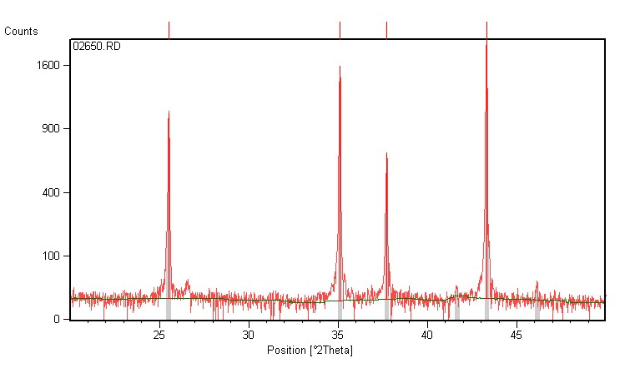 Fig 5.1 0% composition at 1650⁰C (a, b)
b)
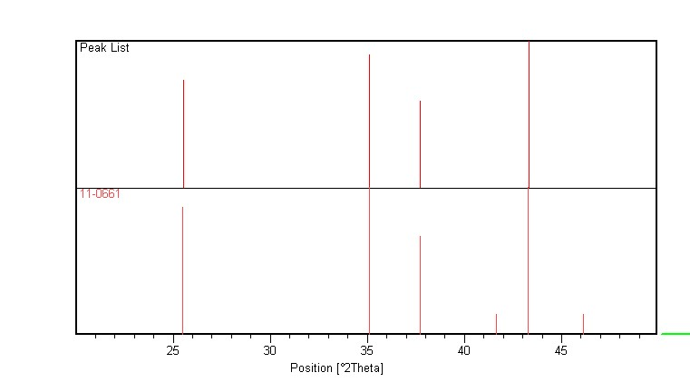

c)
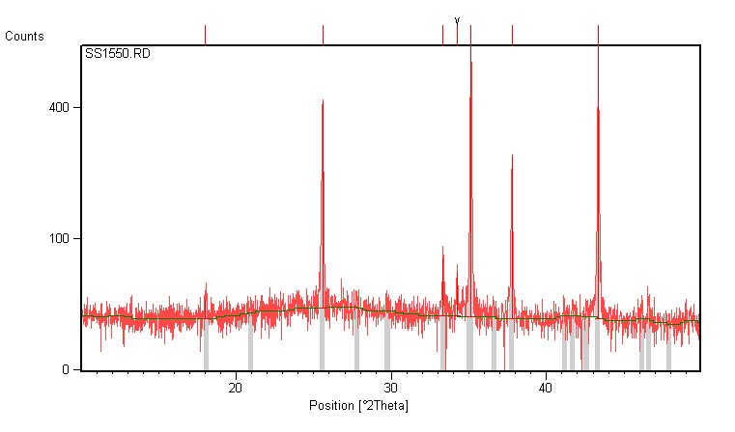
Fig 5.2~ 2% yttria doped alumina at 1550⁰C(c, d)
d)
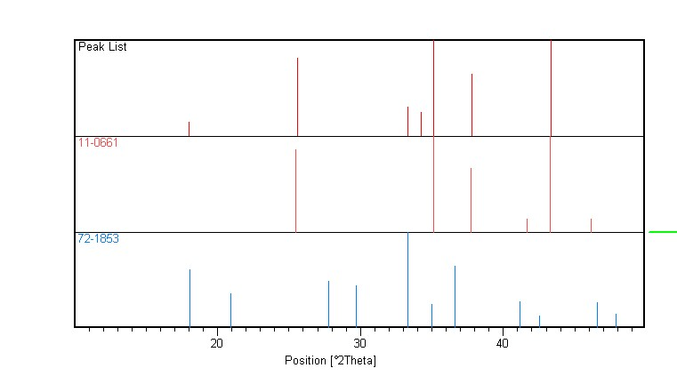
e)
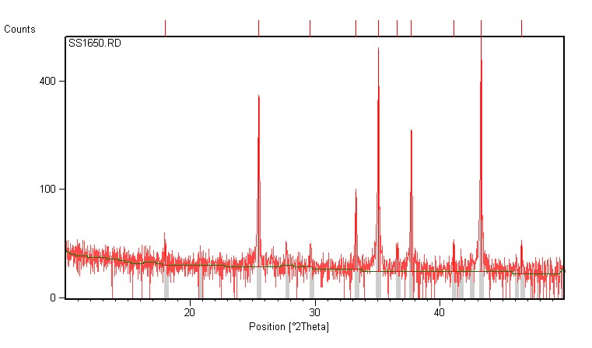
Fig 5.3 2% Yttria doping at 1650⁰C (e, f)
f)
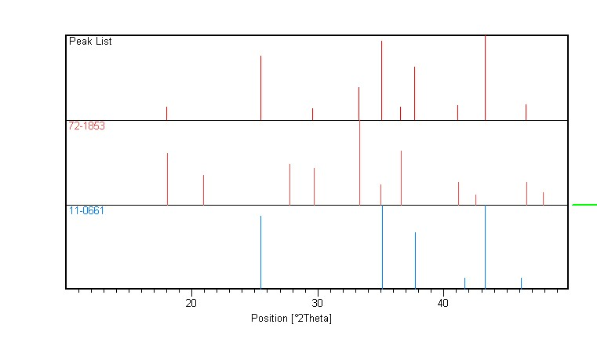
- JCPDF no 11-0661 corresponds to alumina phase
- JCPDF no 72-1853 corresponds to Y₃Al₅O₁₂ phase.
From the XRD results we find that all the peaks correspond to either alumina or yttrium aluminate. This indicates a reaction between alumina and yttria and the phase formation as Y₃Al₅O₁₂.

5.2 Shrinkage
Temperature(⁰C) | 0% | 0.5% | 1% | 2%
1550 | 19.19 | 20.49 | 18.93 | 19.33
1600 | 23.01 | 25.2 | 24.4 | 24.4
1650 | 27.69 | 30.27 | 28.85 | 29.74

From the graph we found that shrinkage increases with increase in temperature as well as with increase in the dopant concentration.

5.3 Bulk Density and Apparent Porosity of sintered pellets:
Bulk Density
Temperature(⁰C) | 0% | 0.5% | 1% | 2%
1550 | 3.01 | 3.05 | 2.97 | 2.97
1600 | 3.26 | 3.21 | 3.15 | 3.14
1650 | 3.34 | 3.38 | 3.39 | 3.38

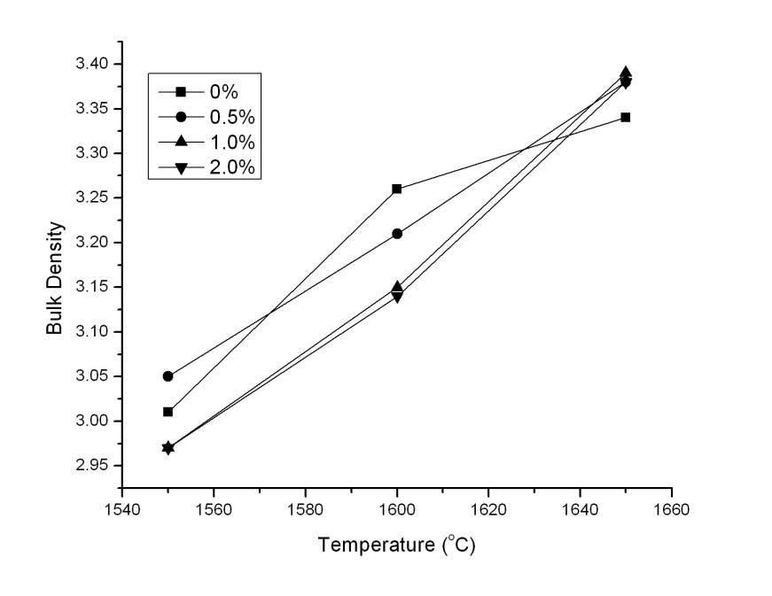
Fig 5.4 Bulk Density vs Temperature
With increase in percentage of additive there is a negative effect on densification for 1550⁰C and 1600⁰C. But for 1650⁰C, density increases marginally from which we can conclude that yttria is effective in densification only after 1650⁰C.

Apparent Porosity
Temperature(⁰C) | 0% | 0.5% | 1% | 2%
1550 | 23.45 | 20.83 | 23.31 | 24.06
1600 | 15.61 | 16.96 | 18.34 | 19.28
1650 | 11.51 | 9.98 | 9.53 | 9.5
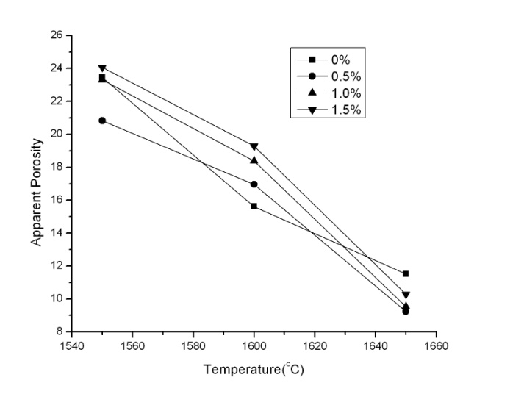
Fig 5.5 Apparent Porosity vs Temperature
From the plot we get that the porosity decreases as we increase the temperature as well as with the increase in the dopant concentration.

5.4 SEM analysis
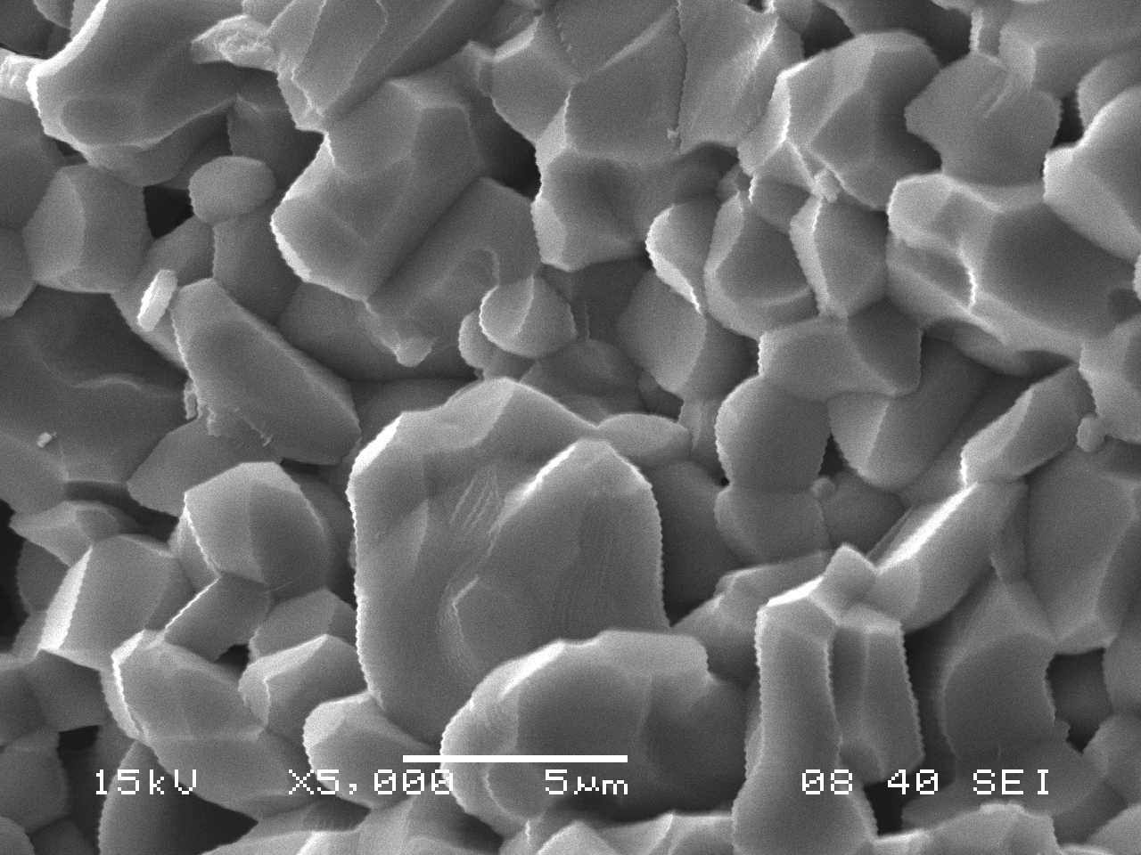 0% Yttria at 1650⁰C
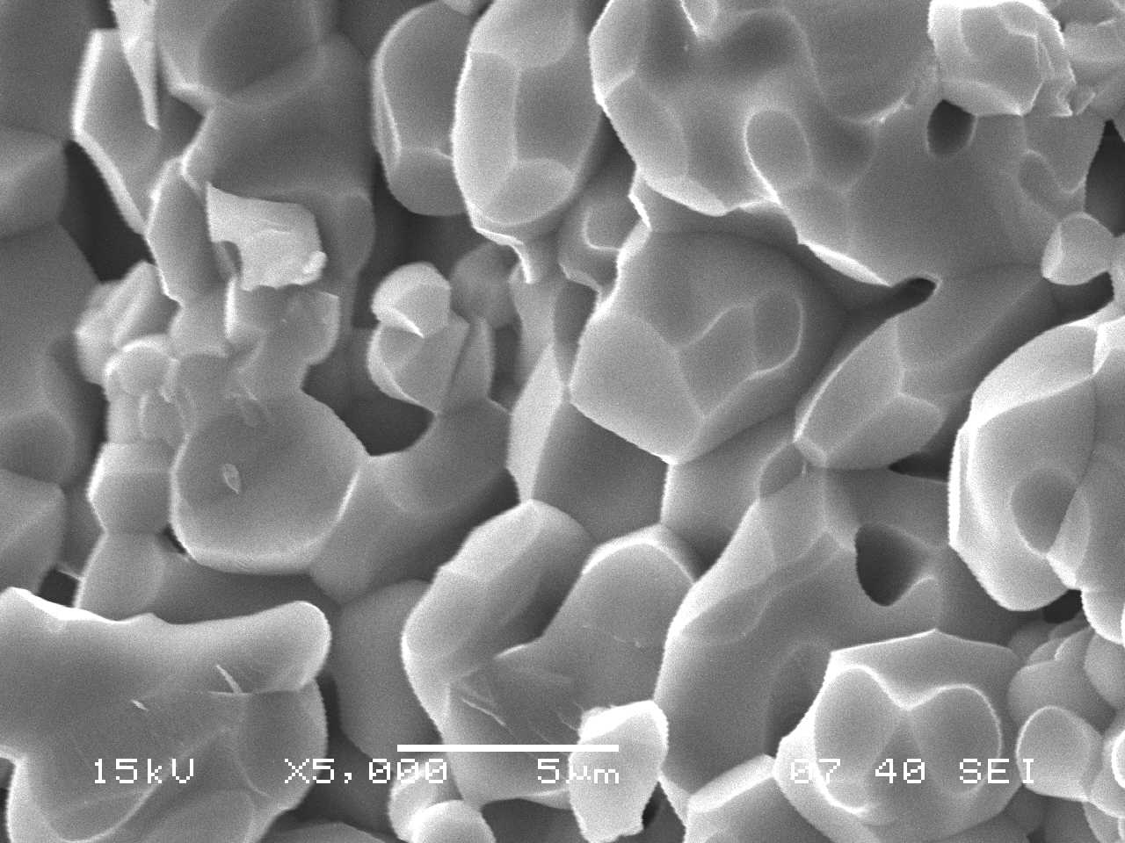 2% Yttria at 1650⁰C
White grains
SEM photomicrographs shows that in 0% composition porosity was higher than that of additive containing composition. Also the variation in grain size is higher in without additive containing composition. Additive containing batch was found to contain some grains which are much brighter in color and EDAX analysis was carried out to analyze these grains. It was found that these grains contain yttrium in it and the other relatively darker grains are pure alumina. Formation of these yttrium aluminate phases were also confirmed by XRD analysis.

5.5 EDAX
EDAX for non-white grains
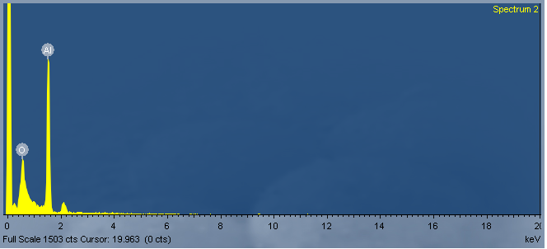
EDAX for white grains
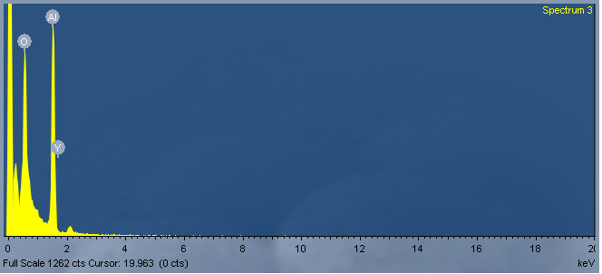

CHAPTER 6~~ CONCLUSION
It may be concluded that
Reaction between alumina and yttria is occurring at high temperature forming Y₃Al₅O₁₂ phase.
Bulk density, apparent porosity and shrinkage values indicate that yttria is effective as dopant only after 1650⁰C.
From SEM, it may be observed betterment in densification has occurred in yttria containing composition and also the phase formation of Y₃Al₅O₁₂ is confirmed (found as white phase) which was analyzed by EDAX.

CHAPTER 7~~ REFERENCES
[1].J.S Reed , Introduction to the Principles of Ceramic Processing, 2nd Ed., John Wiley & Sons. 1995.
[2].W.D Kingery ,Bowen and D.R.Uhlmann, Introduction to Ceramics, 2nd Ed. John Wiley & Sons, Singapore,1991.
[3]M.N Rahaman , Ceramic Processing, CRC Presss, Taylor & Frncis Group, FL, 2007
[4] M. Le Gall¹, A. M. Huntz¹, B. Lesage¹, C. Monty² and J. Bernardini³ (Journal of Materials Science)
[5] The influence of yttrium on the sintering of Al₂O_{3,}D. DELAUNAY, A. M. HUNT2 and P. LACOMBE(Journal of the Less-Common Metals, 70 (1980) 115 - 117)
[6] Effect of Grain Size on Yttrium Grain Boundary Segregation in Fine-grained Alumina
P. Gruffel & C.Carry(Journal of the European Ceramic Society 11 (1993) 189-199)
[7] Yttrium Diffusion in a-alumina single crystal
E. G. Maya, F. Maya, B. Lesage, M. IS. LoudjanP and C. Grattepain(Journal of the European Ceramic Society 18 (1998) 591-594 0 1998 Elsevier Science Limited)
[8] Effects of Y2O3 addition on microwave dielectric characteristics of Al2O3 ceramics
K.X. Song, S.Y. Wu, X.M. Chen(Sciencedirect Materials Letters 61 (2007) 3357–3360)
[9] The effect of yttrium on densification and grain growth in α-alumina.
R. Voytovych, I. MacLaren, M. A. Gülgün, R. M. Cannon and M. Rühle ( Sciencedirect Volume 50, Issue 13, 1 August 2002, Pages 3453-3463)
[10] Effect of yttrium and lanthanum on the final-stage sintering behavior of ultrahigh-purity alumina. Fang, J., Thompson, A.M., Chan, H.M.
[11] www.azom.com

