An Approach towards the synthesis of
furo[3,4-c]pyrazole

A Dissertation
Submitted in partial fulfillment

FOR THE DEGREE OF

MASTER OF SCIENCE IN CHEMISTRY

By

Krushna Chandra Sahoo

Under the Guidance of

Dr. Niranjan Panda



DEPARTMENT OF CHEMISTRY
NATIONAL INSTITUTE OF TECHNOLOGY
ROURKELA – 769008, ORISSA

CERTIFICATE

Dr. Niranjan Panda
Department Of Chemistry,
National Institute Of Technology,Rourkela

This is to certify that the dissertation entitled “An Approach towards the synthesis of furo[3,4-c]pyrazole” being submitted by Krushna Chandra Sahoo to the Department of Chemistry, National Institute of Technology, Rourkela, Orissa, for the award of the degree of Master of Science is a record of bonafide research carried out by him under my supervision and guidance. To the best of my knowledge, the matter embodied in the dissertation has not been submitted to any other University / Institute for the award of any Degree or Diploma.

N.I.T. Rourkela.
Date: Dr. Niranjan Panda
(Supervisor)

ACKNOWLEDGEMENTS

With deep regards and profound respect, I avail this opportunity to express my deep sense of gratitude and indebtedness to Prof. Niranjan Panda, Department of Chemistry, National Institute of Technology, Rourkela, for introducing the present project topic and for her inspiring guidance, constructive criticism and valuable suggestion throughout the project work. I most gratefully acknowledge his constant encouragement and help in different ways to complete this project successfully.
I would like to acknowledge my deep sense of gratitude to Prof. R. K. Patel, Head of Department of Chemistry, National Institute of Technology, Rourkela, and all the faculty members for his valuable advices and constant encouragement for allowing me to use the facilities in the laboratory.
I would also like to thank my labmate Archana, Soumi, Ashish, Vijaya and all my friends for their constant encouragement during the project work. I wish to thank all the staff members of Department of Chemistry for their support and help during the project.
Last but not the least, I remember with gratitude my family members who were always a source of strength, support and inspiration.

Rourkela
Date: (Krushna Chandra Sahoo)

To

MY FATHER

WHO ENCOURAGE ME

TO PROCEED

AT EACH & EVERY STEP

TABLE OF CONTENTS
Page

Introduction ……………………………………………………………………… 1
Result & Discussion……………………...………………………………………. 6
Conclusion…………………………………. ………...………………………….. 8
Experimental Section………………………………………………………….. .9
References------------------------------------------------------------------------------------13

INTRODUCTION
Heteroaromatic compounds have attracted considerable attention in the design of biologically active molecules and advanced organic materials.¹ Hence, a practical method for the preparation of such compounds is of great interest in synthetic organic chemistry. Pyrazole and its derivatives, a class of well known nitrogen containing heterocyclic compounds, occupy an important position in medicinal and pesticide chemistry with having a wide range of bioactivities such as antimicrobial,² anticancer,³ anti-inflammatory,⁴ antidepressant,⁵anticonvulsant,^{5,6} antihyperglycemic,⁷ antipyretic,⁸ antibacterial, ⁹ antifungal activities,¹⁰ CNS regulants,¹¹ and selective enzyme inhibitory activities¹². It has been found that these compounds have hypoglycemic activity, and are also known as inhibitors and deactivators of liver alcohol dehydrogenase and oxidoreductases.¹³ It has been shown in vivo that some of the pyrazole derivatives have appreciable antihypertensive activity.¹⁴ These compounds also exhibit properties such as cannabinoid hCB1 and hCB2 receptor, , inhibitors of p38 Kinase, CB1 receptor antagonists^{15,16} .The biological activity of certain pyrazole derivatives have been discussed here .

The 1-phenylpyrazole motif is present in several drug candidates for treatment of various diseases such as cyclooxygenase-2 (Cox-2) inhibitors, IL-1 synthesis inhibitors, and protein kinase inhibitors etc. Similarly a few of the 1,5-diarylpyrazole derivatives have been shown to exhibit non-nucleoside HIV-1 reverse transcriptase inhibitory activities along with Cox-2 inhibitor.¹⁷
Several substituted pyrazolo[3,4-d]pyrimidine derivatives have xanthine oxidase inhibitor activity^{18,} like allopurinol which was first synthesized by Robins in 1956 and is still the drug for the treatment of hyperuricemia and gouty arthritic disease.¹⁹
The pyrazolo[1,5-a]pyrimidines e.g. Indiplon (1a) and Zaleplon (1b) and the N,N-dialkyl-2- phenylacetamidoimidazo[1,2-a]pyridines e.g. Zolpidem (2a) and Alpidem (2b) are also used for the treatment of anxiety sleep disorders, convulsions, and memory deficits.²⁰
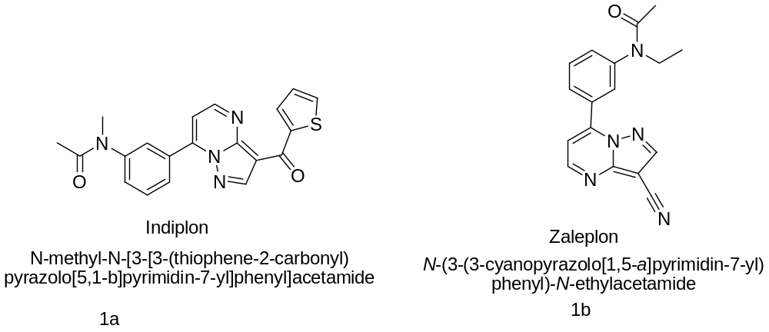
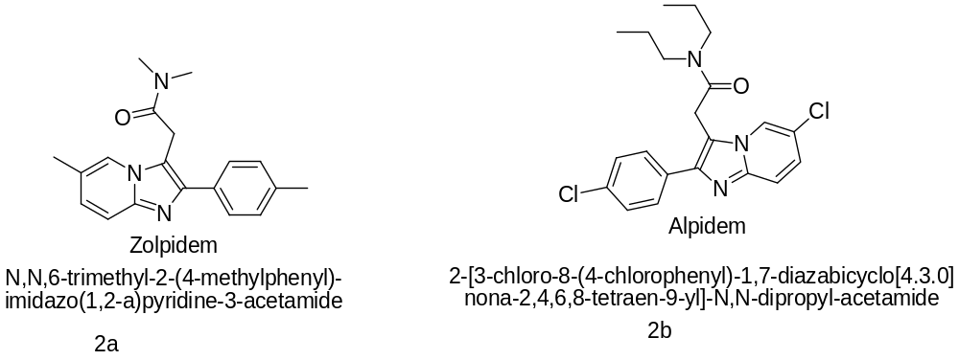

Urea derivatives of 5-aminopyrazoles have recently been reported as potent inhibitors of P³⁸ kinase, TNF-α production, and cholesterol acyltransferase.²¹
Curcuminoid pyrazoles are used as new therapeutic agents in inflammatory bowel disease. The activity of the curcuminoid pyrazoles covers domains such as anti-inflammatory (5-lipooxygenase and cyclooxygenase inhibitors), antitumoral (anti-angiogenic) and drugs for the treatment of the Alzheimer disease.²²

The importance of pyrazole exploited from the appearance of some pesticides in the market in the name of fripronil (Colliotet al., 1992) (3), topramezon (BASF, 2006)(4), pyraelostrobin (BASF,2001)(5) etc.²³

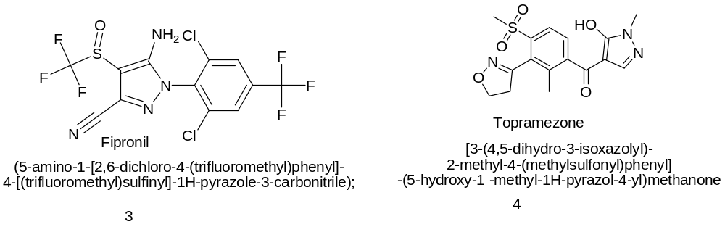

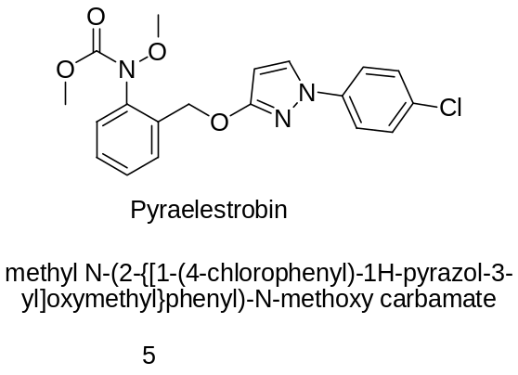

The pyrazole ring is a constituent of a variety of natural and synthetic products. Examples of pyrazole ring containing natural products are (S)-3-pyrazolylalanine(6), pyrazomycine(7), and 4,5-dihydro-3-phenyl-6H-pyrrolo[1,2–b]pyrazole (8), while lonazolac (9), fezolamin (10),difenamizole (11), and mepirizole(12) are examples of biologically active synthetic pyrazole derivatives .

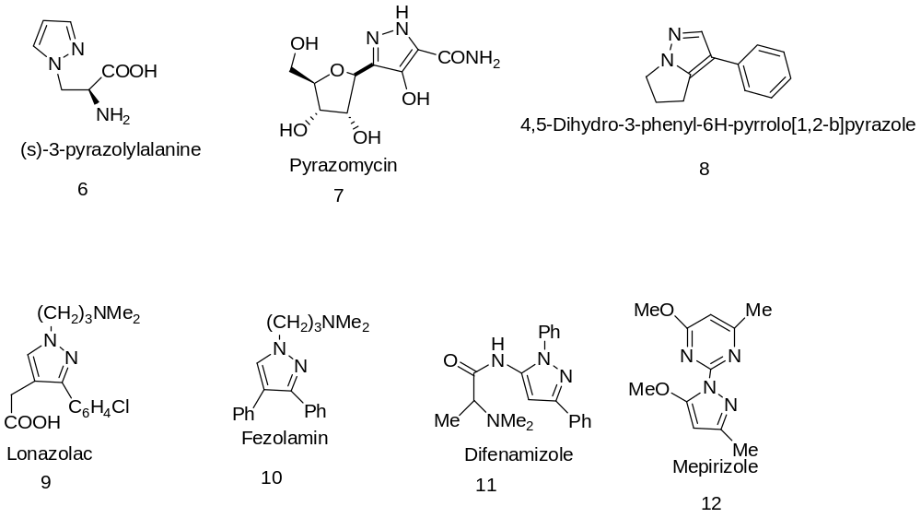

Pyrazoles are usually prepared by condensation between a hydrazine derivative and a 1,3-dicarbonyl compound or by 1,3-dipolar cycloaddition of diazoalkanes or nitrile imines to olefins or acetylenes.²⁴ Here, in this report our approach towards the synthesis of some polycyclic pyrazole compounds by the Diels-Alder reaction of furo[3,4-c]pyrazole and several dienophiles is disclosed. As furo[3,4-c]pyrazole is unknown till now, we want to focus our study for the synthesis of furo[3,4-c]pyrazole. Our approach towards furo[3,4-c]pyrazole and subsequent [4+2]cycloaddition reaction is outlined in Scheme 1.

Scheme 1

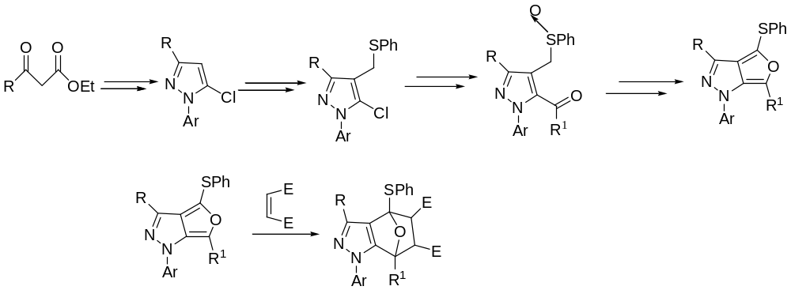

RESULT AND DISCUSSION

The most important methods for preparing this class of heterocycles are the reaction between hydrazines with β-difunctional compounds²⁵ and 1, 3-dipolar cycloadditions of diazo compounds onto triple bonds²⁶. The former process, considered to be the best method for the preparation of pyrazoles, involves the double condensation of 1, 3-diketones with hydrazine or its derivatives.²⁷ This method has a wide scope not only because of the readily availability of 1, 3-diketones but also because one carbonyl of the diketone starting material can be replaced by an acetal, a hemiacetal, a chlorovinyl group, dihalides, etc.²⁵
The conventional method of preparation of pyrazole or pyrazole derivatives involving condensation of 1,3-diketones with phenyl hydrazine or its derivatives require long time (7-8 hrs) with lower yield. And it requires organic toxic solvent as a reaction medium. But we have developed an efficient method of synthesis pyrazole type of compound by solvent free reaction of 1,3-diketone with phenyl hydrazine under microwave irradiation in short time (8-10 min). Thus the reaction of 1,3- dicarbonyl compound with phenyl hydrazine in silica gel G support under microwave irradiation for 8-10 mins give pyrazolone (14) in excellent yield.14b shows a characteristic absorption peak at 1709 cm⁻¹ (C=O stretching ).Reaction of 14 with phosphorous oxychloride 80-90⁰c result in the chlorination at C-5 position to form 5-chloro-pyrazole derivative 15 (Scheme 2). Formation of 15b is evident from ¹H NMR spectrum, which shows signals at δ 7.77-7.17 (m) for 10 protons of phenyl ring and another singlet at 6.63 for the C4-H proton.

Scheme 2
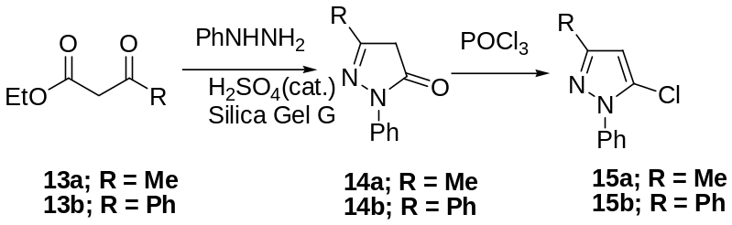

Pyrazole derivative 15 was selectively formylated at C-4 using Vilsmeier-Haack reaction condition (Scheme 3). Formation of 16a was confirmed from IR as well as NMR spectroscopy. 16a shows characteristic IR absorption band at 1676.73 cm⁻¹ (C=O stretching) and a sharp singlet at δ 9.92 for CHO, at δ 2.491 for –CH₃. Similarly IR spectrum of 16b show a strong absorption band at 1683cm⁻¹ (C=O stretching), ¹H NMR spectrum, which shows signals at δ 7.20-7.78 for aromatic protons .Reactions of 16a with NaBH₄ result in the reduction of aldehyde group alcohol 17 (Scheme 4).

Scheme -3

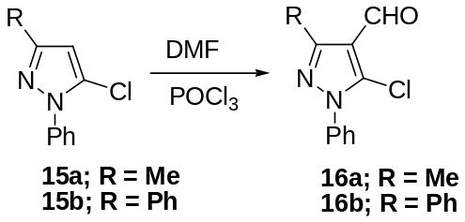

Scheme-4
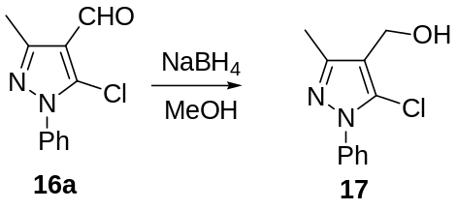
In order to introduce a thiophenyl group, we chlorinated the alcohol by oxalyl chloride and nucleophilically substituted the chloro group by thiophenolate ion in-situ without isolation of the chloro compound 18 (Scheme 5).
Scheme-5
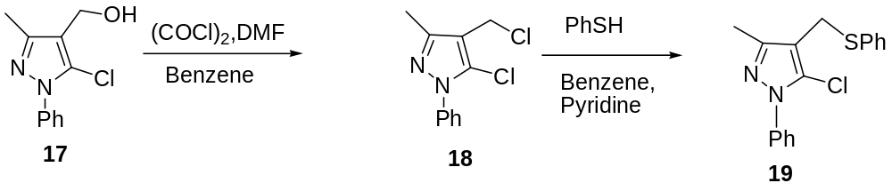

CONCLUSION
The present work embodies the synthesis of pyrazole derivative in solid phase under microwave irradiation of β-dicarbonyl compounds with phenylhydrazine within a very short time (8-10 min) in good yield. The transformation of the pyrazolone to the precursor for Pummerer reaction which may lead to furo[3,4-Ic]pyrazole is an ongoing work in our laboratory and will be reported in due course.

EXPERIMENTAL SECTION

3-methyl-1-phenyl-1H-pyrazol-5(4H)-one (14a)

To a mixture of ethyleacetoacetate (3.84mmol, 0.49ml) and phenyl hydrazine (3.84mmol, 0.38ml) a drop of concentrated H₂SO₄ was added. To this mixture 2gm of silica gel G was added and it was grinded thoroughly. The mixture was heated in a microwave for 8-10 minutes. Then it was washed with CH₂Cl₂ repeatedly and the extract was dried over anhydrous Na₂SO₄ and the solvent was removed under vacuum yielding yellow solid which was washed with petroleum ether and 2% polar solution to give the pure product as light yellow crystalline solid.
Yield-69%

1, 3-diphenyl-1H-pyrazol-5(4H)-one (14b)

1,3-diphenyl-1H-pyrazol-5(4H)-one (2b) was obtained by the condensation of ethylebenzoyl acetate (500mg, 2.6011mmol) and phenyl hydrazine (0.257ml, 2.6011ml) following the same procedure as described for compound 2a in the form of yellow crystalline solid.
Yield-85.16%

IR (KBr)-1709.61cm⁻¹

5-chloro-3-methyl-1-phenyl-1H-pyrazole (15a)

A mixture of 3-methyl-1-phenyl-1H-pyrazol-5(4H)-one (3.7gm, 21.264mmol) and phosphorous oxychloride (7.93ml, 85.056mmol) was stirred under nitrogen atmosphere at 80-90⁰ for 7hrs. Then the reaction mixture was cooled to room temperature and poured into ice-cold water and neutralized by careful addition of saturated solution of NaHCO₃ in small portions with stirring. The resulting mixture was then extracted with CH₂Cl₂ repeatedly. The combined layer was washed with brine solution and dried over anhydrous Na₂SO₄ and the organic layer was dried under vacuum. The crude compound was then purified by column chromatography.
Yield-65.6%

5-chloro-1, 3-diphenyl-1H-pyrazole (15b)

1,3-diphenyl-1H-pyrazol-5(4H)-one (3gm,12.962mmol) was taken with phosphorous oxychloride (POCl₃ ,4.83ml,51.85mmol) and proceeding as for compound 3a we get 5-chloro-1, 3-diphenyl-1H-pyrazole.
Yield-84.78% ¹H NMR (300MHz) δ 7.77-7.17(m, 10H, ArH), 6.63(s, 1H, CH),

5-chloro-3-methyl-1-phenyl-1H-pyrazole-4-carbaldehyde (16a)

Dimethylformamide (DMF) (5ml) and phosphorous oxychloride (4.728ml, 0.515mmol) were mixed under ice cold condition at nitrogen atmosphere. Then it was allowed to come to room temperature and stirred for 30 minutes. 5-chloro-3-methyl-1-phenyl-1H-pyrazole (2gm, 10.38 mmol) dissolved in DMF was added to it and then heated at 80-90⁰ for 8hrs under nitrogen atmosphere. Then it was cooled to room temperature. The reaction mixture was poured to ice cold water followed by neutralization with saturated solution of NaHCO₃. Then the resulting mixture was extracted with CH₂Cl₂ repeatedly and the organic layer was dried over anhydrous Na₂SO₄ and concentrated under reduced pressure. The black crude compound was purified by column chromatography yielding 5-chloro-3-methyl-1-phenyl-1H-pyrazole-4-carbaldehyde as white crystalline solid.
Yield-78%
IR (KBr)-1676cm⁻¹ ,¹H NMR δ 7.19-7.82(Phenyl H), 9.92(Aldehyde H),2.4(-CH₃),

5-chloro-1,3-diphenyl-1H-pyrazole-4-carbaldehyde (16b)

5-chloro-1,3-diphenyl-1H-pyrazole (3b) was taken and white crystals of 5-chloro-1,3-diphenyl-1H-pyrazole-4-carbaldehyde was synthesized following the procedure given for compound 16a.
Yield-71%
IR-1683.61cm⁻¹

5-chloro-3-methyl-1-phenyl-1H-pyrazol-4-yl) methanol (17)

To a stirred solution of 5-chloro-3-methyl-1-phenyl-1H-pyrazole-4-carbaldehyde (1.8 gm, 8.163mmol) in ethanol (5ml), sodium borohydride (NaBH₄) was added gradually in ice cold condition. Then it was allowed to stir for 6-7 hours at room temperature. The reaction mixture was then extracted with CH₂Cl₂ and washed with dilute HCl. The organic layer was dried over anhydrous Na₂SO₄ and concentrated under reduced pressure to get (5-chloro-3-methyl-1-phenyl-1H-pyrazol-4-yl) methanol as white solid.
Yield -63.31%

5-chloro-4-(chloromethyl)-3-methyl-1-phenyl-1H-pyrazole (18)

To a stirred solution of (5-chloro-3-methyl-1-phenyl-1H-pyrazol-4-yl) methanol(1.6g,7.19mmol) in benzene(10-12 ml) was added 1 drop of DMF and oxalyl chloride (1.376 ml,17.975mmol) under nitrogen atmosphere. Then the reaction mixture was heated at reflux for 2-3 hrs. Then the solvent was removed under reduced pressure and the intermediate compound 6 was subjected to next step immediately without further purification.

5-chloro-3-methyl-1-phenyl-4-((phenylthio)methyl)-1H-pyrazole(19)

To the above resulting gummy liquid 5ml of dry benzene was added. Then thiophenol was added drop wise at 0⁰. Then to this well stirred solution 0.5ml of pyridine was added and stirred. Then the reaction mixture was allowed to come at room temperature and stirred for 2hrs. Then the reaction mixture was poured in to water and extracted with CH₂Cl₂.The organic layer was washed with dil. HCl and dried over anhydrous NaSO₄. Then the solvent was removed under reduced pressure and the resulting mixture was purified by column chromatography.

REFERENCE

(1) (a) Zificsak, C. A.; Hlasta, D. J. Tetrahedron 2004, 60, 8991. (b)Haino, T.; Tanaka, M.; Ikeda, K.; Kubo, K.; Mori, A.; Fukazawa, Y. Tetrahedron Lett. 2004, 45, 2277
(2) Boyne, M.; Stratton, C.; Johnson, F.; Tonge, P. ACS Chem. Biol. 2006, 1, 43.
(3) Magedov, I. V.; Manpadi, M.; Van slambrouck, S.; Steelant,W. F. A.; Rozhkova, E.; Przheval’skii, N. M.; Rogelj, S.;Kornienko, J. Med. Chem. 2007, 50, 5183–5192..
(4) Rovnyak, G. C.; Millonig, R. C.; Schwartz, J.; Shu, V. J. Med. Chem. 1982, 25, 1482–1488
(5)(a) Palaska, E.; Aytemir, M.; Uzbay, IT.; Erol, D. Eur. J. Med. Chem. 2001, 36, 539-543.
(b) Rajendra, P. Y.; Lakshmana, R. A.; Prasoona, L.; Murali, K.; Ravi, K. P. , Bioorg. Med. Chem. Lett. 2005, 15, 5030-5034.
(6)(a) Ozdemir, Z.; Kandilici, B.; Gumusel, B.; Calis, U.; Bilgin, A.,Eur. J.Med. Chem. 2007, 42, 373-379.
(b) Ruhogluo, O.; Ozdemir, Z.; Calis, U.; Gumusel, B.; Bilgin, A., Arzneimittelforschung 2005, 55, 431-436.
(7) Hees, K. L.: Fitzgerald, J. J.; Steiner, K. E.; Mattes, J. F.: Mihan, B.; Tosi, T.; Mondoro, D.;
McCaleb, M. L. J. Med. Chem., 1996, 39, 3920-3928.
(8) Sener A, Kasımog˘ulları R, Sener MK, Bildirici I, Akcamur Y (2002) J Heterocyclic Chem 39:869
(9) Liu, X. H.; Cui, P.; Song, B. A.; Bhadury, P. S.; Zhu, H. L.; Wang, S. F. ,Bioorg. Med. Chem. 2008, 16, 4075–4082
(10) Akbas E, Berber I (2005) Eur J Med Chem 40:401
(11) P Schmidt, K. Eichenberger. and M. Wilhelm, Angew. Chem., 73, 15 (l96l):
(12) Wachter, G. A.; Hartmann, R. W.; Sergejew, T.; Grun, G. L.; Ledergerber, D., J. Med. Chem. 1996, 39, 834–841
(13) (a) Katritzky, A. R.; Rees, C. W.; Scriven, E. F. V.. In Comprehensive Heterocyclic
Chemistry; Potts Kevin, T., Ed.; Pergamon: Oxford, 1984; 5, p 291; (b) Camacho,
M. E.; Leon, J.; Entrena, A.; Velasco, J.; Cfrrion, M. D.; Escamaes, G.; Vivo, A.;
Acuna-Castroviego, D.; Gallo, M. A.; Espinosa, A. J. Med. Chem. 2004, 47, 5641–5650;
(14) Demirayak, S.; Karaburum, A. S.; Beis, R. Eur. J. Med. Chem. 2004, 39,1089–1095.
(15) Silvestri, R.; Cascio, M. G.; Regina, G. L.; Piscitelli, F.; Lavecchia, A.; Brizzi, A.;
Pasquini, S.; Botta, M.; Novellino, E.; Marzo, V. D.; Corelli, F., J. Med. Chem. 2008, 51, 1560.
(16) Graneto, M. J.; Kurumbail, R. G.; Vazquez, M. L.; Shieh, H-S.; Pawlitz, J. L.;
Williams, J. M.; Stallings, W. C.; Geng, L.; Naraian, A. S.; Koszyk, F. J.; Stealey, M.
A.; Xu, S. D.; Weier, R. M.; Hanson, G. J.; Mourey, R. J.; Compton, R. P.; Mnich, S.
J.; Anderson, J. D.; Monahan, J. B.; Devraj, R. J. Med. Chem. 2007, 50, 5712.
(17) (a) Meegalla, S. K.; Doller, D.; Liu, R.; Sha, D.; Soll, R. M.; Dhanoa, D. S. Tetrahedron Lett. 2002, 43, 8639. (b) Dannhardt, G.; Laufer, S. Curr. Med. Chem. 2000, 7, 1101. (c) Ashton, W. T.; Hutchins, S. M.; Greenlee, W. J.; Doss, G. A.; Chang, R. S. L.; Lotti, V. J.; Faust, K. A.; Chen, T.-B.; Zingaro, G. J.; Kivlighn, S. D.; Siegl, P. K. S. J.Med. Chem. 1993, 36, 3595.
(18) (a) Kobayashi, S. Chem. Pharm. Bull. 1973, 21, 941. (b) Robins, R. K.; Revankar, G. R.; O’Brien, D. E.; Springer, R. H.; Novinson, T.; Albert, A.; Senga, K.; Miller, J. P.; Streeter, D. G., J. Heterocycl. Chem. 1985, 22, 601.
(19) Robins, R. K. J. Am. Chem. Soc. 1956, 78, 784
(20) (a) George, P.; Rossey, G.; Depoortere, H.; Mompon, B.; Allen, J.; Wick, A. Imidazopyridines: towards novel hypnotic and anxiolytic drugs. Il Farmaco 1991, 46, 277–288. (b) Browne, L.J.; Shaw, K.J. New anxiolytics, Annu. Rep. Med. Chem. 26 (1991) 1–10.
(21) (a)Duma, J.; Hatoum-Mokdad, H.; Sibley, R.; Riedl, B.; Scott, W. J.; Monahan, M. K.; Lowinger, T. B.; Brennan,C.; Natero, R.; Turner, T.; Johnson, J. S.; Schoenlebar, R.; Bhargava, A.; Wilhelm, S. M.; Housley, T. J.; Ranges, G. E.; Shrikhande, A. Bioorg. Med. Chem. Lett. 2000, 10,2051.(b). Regan, J. R.; Cirillo, P. F.; Hickey, E. R.; Moss, N.; Cywin, C. L.; Pargellis, C.; Gilmore, T. A. PCT Int. Appl. WO 9923091, 1999; Chem. Abstr. 1999, 130, 325145.(c) Creswell, M. W.; White, A. D. U.S. Patent 5,162,360, 1993; Chem. Abstr. 1993, 118, 147556
(22) Narlawar, R.; Pickhardt, M.; Leuchtenberger, S.; Baumann, K.; Krause, S.; Dyrks, T.; Weggen, S.; Mandelkow, E.; Schmidt, E. ChemMedChem 2008, 3, 65
(23) Guiping Ouyang, Zhuo Chen, Xue-Jian Cai, Bao-An Song *, Pinaki S. Bhadury, Song Yang, Lin-Hong Jin, Wei Xue, De-Yu Hu, Song Zeng .Bioorganic & Medicinal Chemistry 16 (2008) 9699–9707
(24) (a) J. Elguero, “Pyrazoles” in “Comprehensive Heterocyclic Chemistry II”, ed. by A. R. Katritzky, C. W. Rees, and E. F. V. Scriven, Vol. 3, Elsevier Science Ltd., Oxford, 1996, pp. 1–75.(b) G. Varvounis, Y. Fiamegos and G. Pilidis, Adv. Heterocycl. Chem. 2001, 80, 73.
(c) Stanovnik and J. Svete, “Pyrazoles” in “Science of Synthesis, Houben-Weyl Methods of Organic Transformations”, Vol. 12, Georg Thieme Verlag, Stuttgart, 2002, pp. 15–225
(25) Kost, A. N.; Grandberg, I. I. Adv. Heterocycl. Chem. 1966, 6, 347-429
(26) Padwa, A. 1,3-Dipolar Cycloaddition Chemistry; John Wiley & Sons: New York, 1984; Vol. I.
(27) Wiley, R. H.; E., H. P. Org. Synth. 1951, 31, 43-44.

FTIR
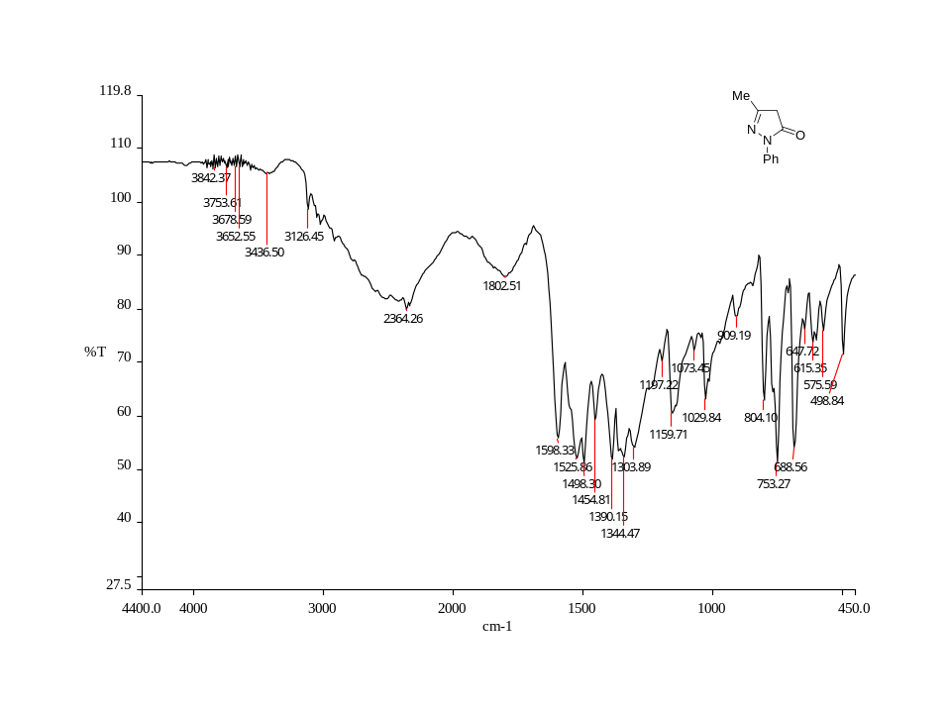

Fig. 1: IR spectra of 3-methyl-1-phenyl-1H-pyrazol-5(4H)-one(14a)

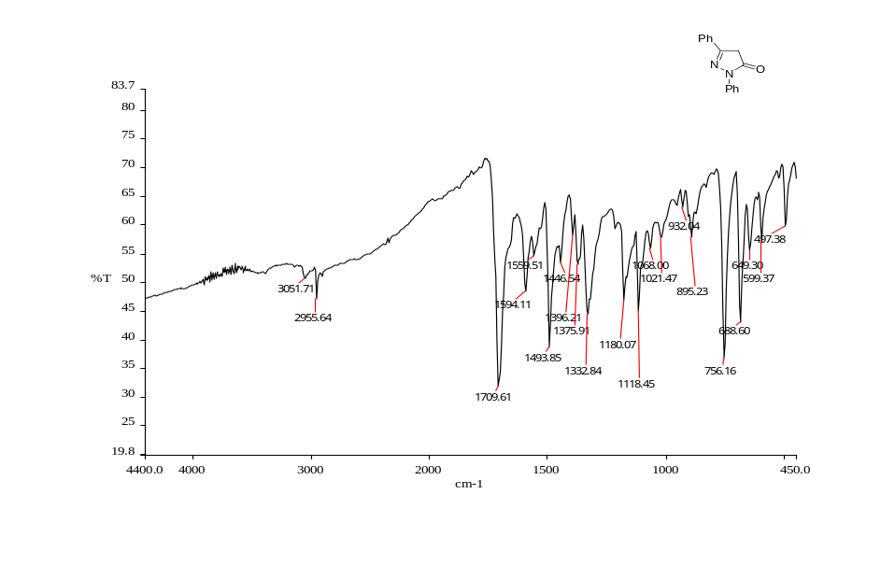
Fig. 2: IR spectra of 1, 3-diphenyl-1H-pyrazol-5(4H)-one (14b)

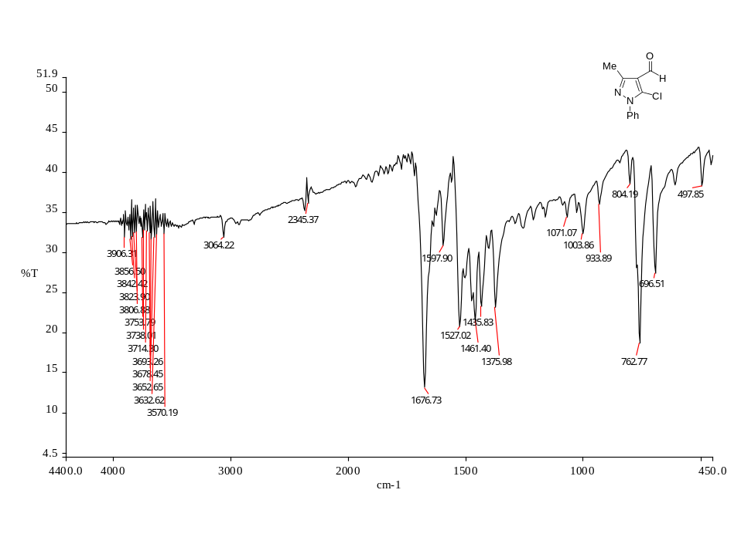
Fig. 3: IR spectra of 5-chloro-3-methyl-1-phenyl-1H-pyrazole-4-carbaldehyde(16a)
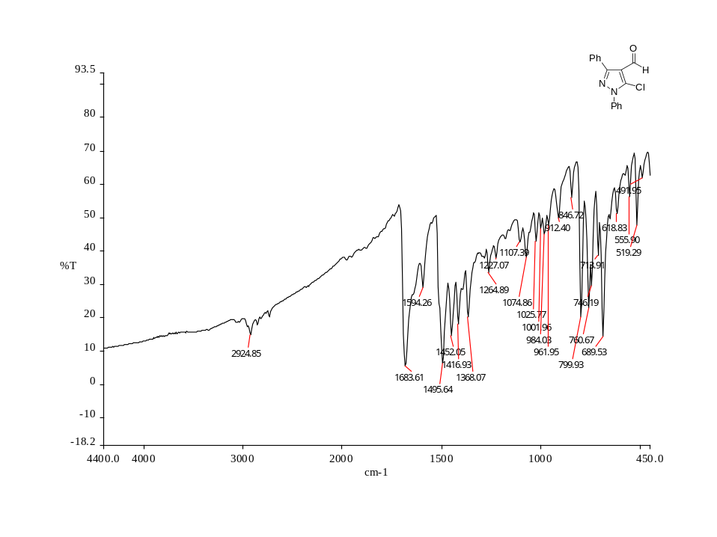
Fig.6: IR spectra of 5-chloro-1,3-diphenyl-1H-pyrazole-4-carbaldehyde (16b)

